**EXPERIMENT-21**

**MICROSOFT AZURE**

**Create a Simple Web Application using Java or Python and host it in any Public Cloud Service Provider (Azure/GCP/AWS) to demonstrate Platform as a Service (PaaS).**

STEP-1:GO TO THE APP SERVICES CREATE A STATIC WEB APP AND FILL THE BASICS.

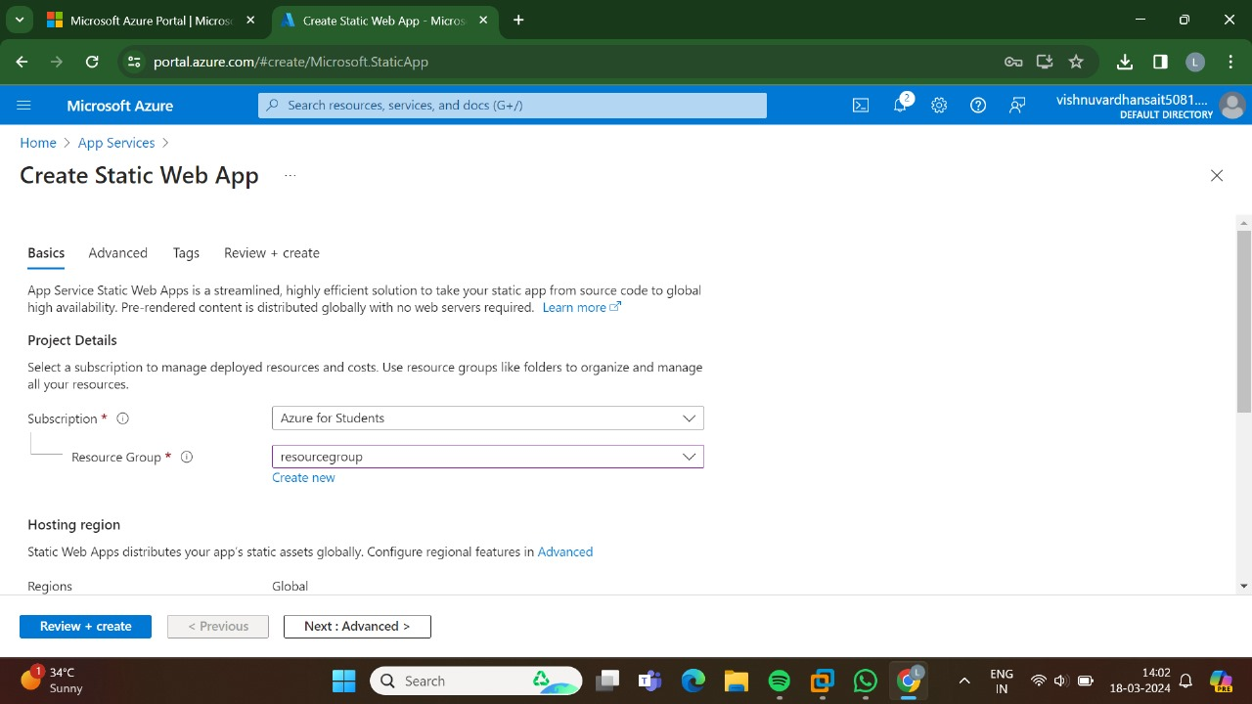

STEP-2: AND, THEN GO FOR THE ADVANCED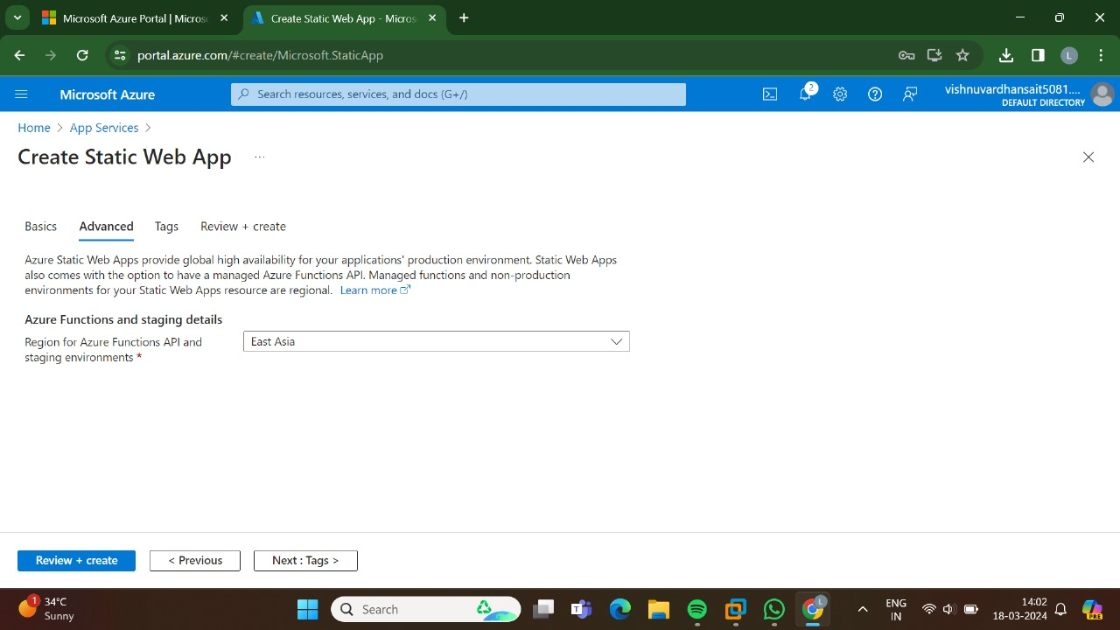

STEP-3:AND, THEN GO FOR THE TAGS.

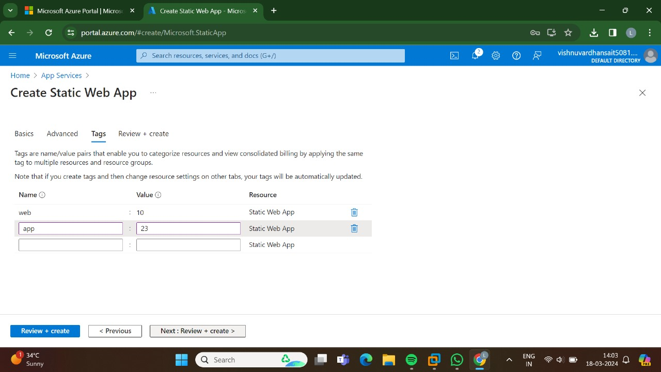

STEP-4:AND, THEN GO FOR THE REVIEW +CREATE AND THEN CLICK CREATE.

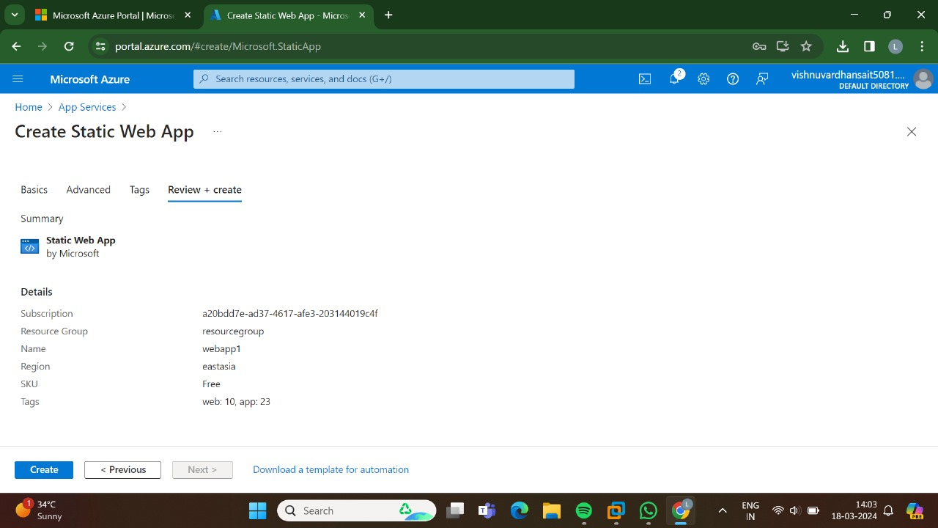

STEP-5:NOW, THE DEPLOYMENT IS IN PROGRESS.

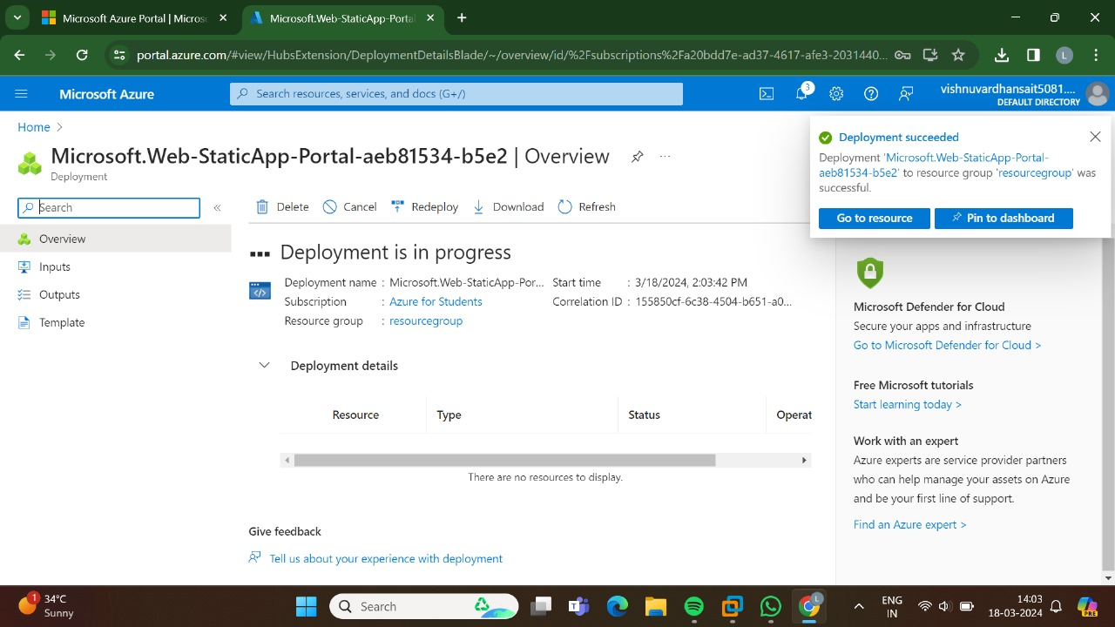

STEP-6:THE DEPLOYMENT HAS BEEN DONE SUCCESSFULLY.

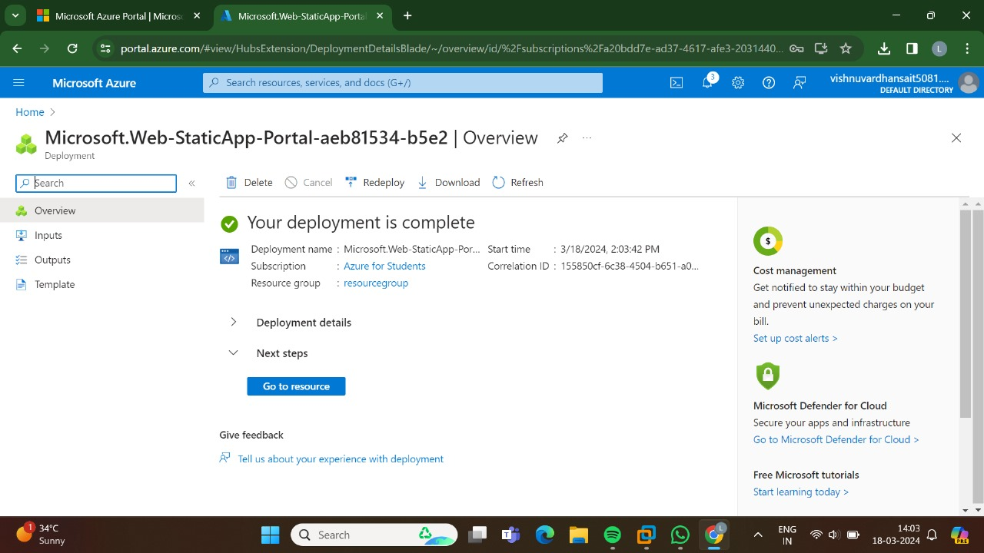

STEP-7:AND, NOW GO TO THE URL.

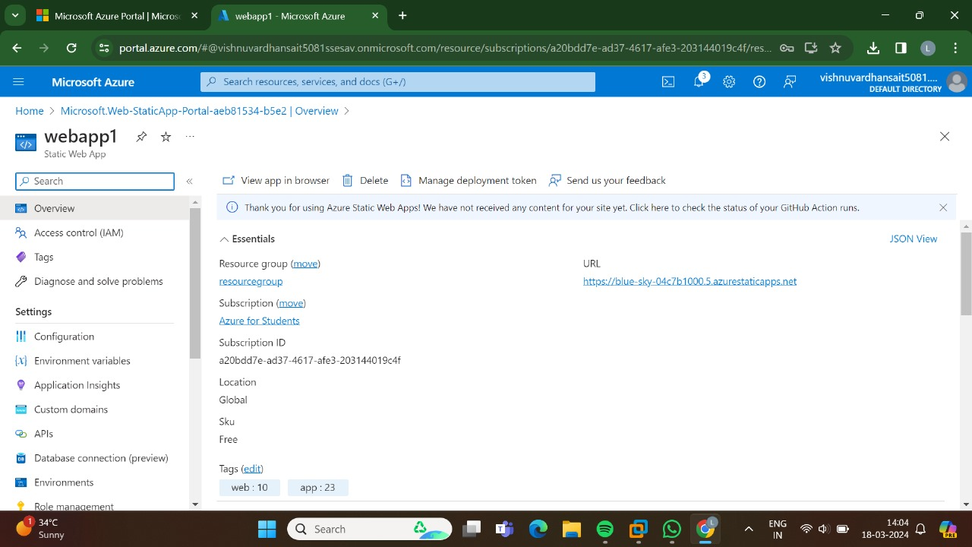

STEP-8: THUS, THE NEW WEB APP HAS BEEN CREATED SUCCESSFULLY.

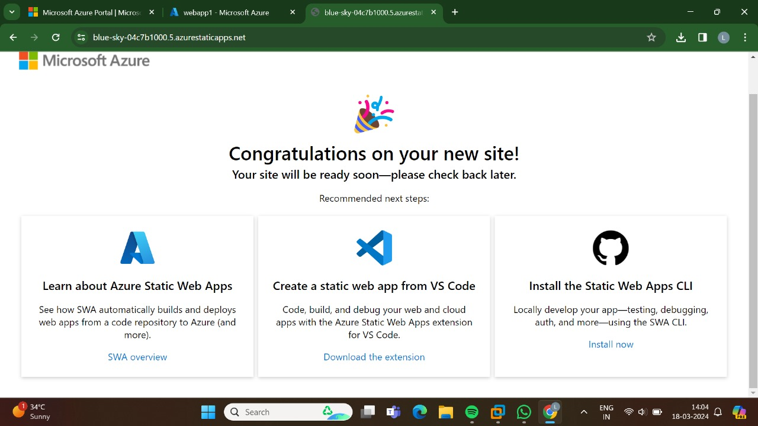

RESULT: THUS, THE PROGRAM FOR THE WEB APPLICATION HAS BEEN EXECUTED SUCCESSFULLY.